**BANK LOAN REPORT QUERY DOCUMENT**

1. **BANK LOAN REPORT | SUMMARY**

**Total Loan Applications**





**MTD Loan Applications**





**PMTD Loan Applications**

**Total Funded Amount**





**MTD Total Funded Amount**



**PMTD Total Funded Amount**



**Total Amount Received**



**MTD Total Amount Received**

**PMTD Total Amount Received**



**Average Interest Rate**





**MTD Average Interest Rate**





**PMTD Average Interest Rate**



**Average DTI**





**MTD Average DTI**

**PMTD Average DTI**



**GOOD LOAN ISSUED**

**Good Loan Percentage**

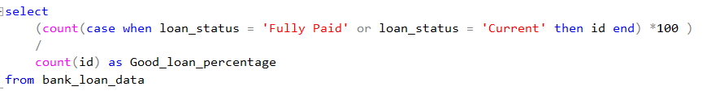

**Good Loan Applications**

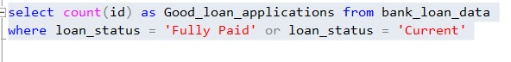

**Good Loan Funded Amount**

**Good Loan Amount Received**

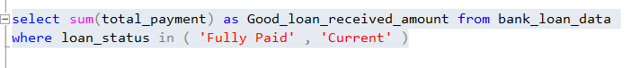

**BAD LOAN ISSUED**

**Bad Loan Percentage**

**Bad Loan Applications**

**Bad Loan Funded Amount**

**Bad Loan Amount Received**



**Loan Status**

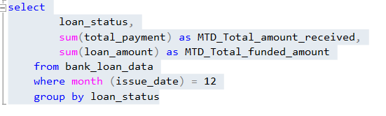

1. **BANK LOAN REPORT | OVERVIEW**

**MONTH**

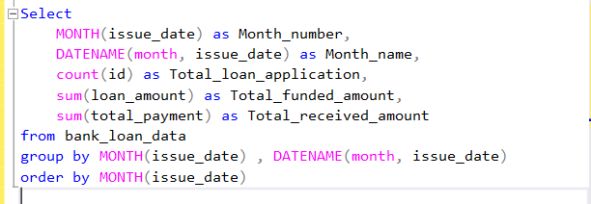

**STATE**

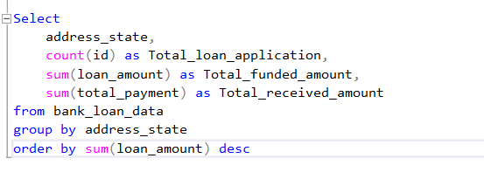

**TERM**

**Employee Length**

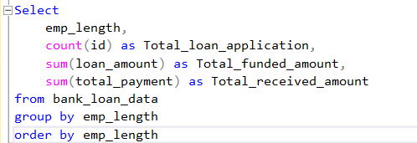

**Purpose**

**Home Ownership**



